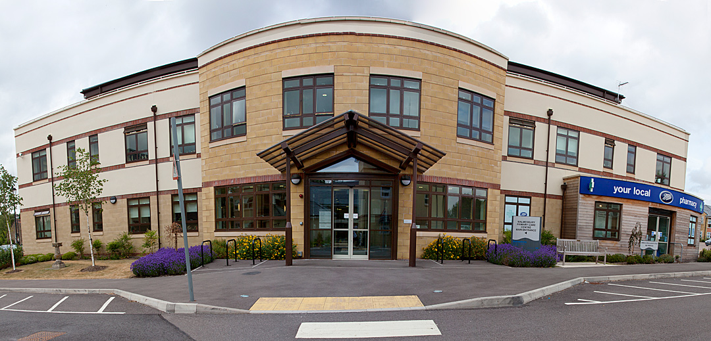

Malmesbury Primary Care Centre
PATIENTS PARTICIPATION GROUP
Minutes of the meeting held on February 1st at 7.00pm

1. Present: Margaret Perrin, Dave Grogan, Frank Soden, Elizabeth Cheshire. Roger Lee. Jennifer Walker, Michael Lynch. Miriam Nicholls, Marion Burfield, Diane Vincent

Apologies: Denise Richards, Georgina Carter ,Carl Hall, Ces Smith

2. Minutes of the last meeting were agreed: Proposed: Seconded:
3. Matters arising from previous meeting: None

Surgery Update:

CQC:
The surgery has no further information at present regarding the imminent visit by the CQC

Blood centrifuge:
There has been a slight delay in the delivery of the equipment from the RUH; Dave has been assured that the equipment is on its way.

Staffing:
The additional two new healthcare Assistants and a Practice Nurse are settling in well.

Referrals:
A member of the group asked how patients can find out how long they may have to wait for an appointment from a specialist when a doctor refers them for treatment: A number of the PPG have used the Referral Centre successfully to attain this information and advised that this was a possible route to take.

Duty Doctor: There is now a slightly different model of Duty Doctor being trialled at the Surgery and will be called “Urgent Care Clinic”. The Duty GP and Duty (Minor Illnesses) Nurse will work as a team and both are located with the Nurse on the ground floor. It is hoped this joint working will improve the care given to patients requiring urgent care. This service started 1st February 2016 and will initially be available afternoons only.

Other areas of concern:

Chemotherapy unit update: An announcement has been made in the local paper stating that the Malmesbury league of friends have donated £25,000 towards a new cancer unit which has been given the green light to be built at the Great Western Hospital. This will save the patients in North Wiltshire travelling to Oxford for cancer treatment. Dave had a meeting at the surgery with Estate managers from Great Western Hospital and they promised to get back to him with an explanation as to why the mobile Chemotherapy Unit does not visit the Malmesbury surgery.

3 monthly PPG meetings: The group took a vote to see if anyone wished to change the meetings to three monthly sessions. It was unanimously agreed by the PPG members that the meeting dates should be kept as they are at present.

Music in the waiting area: It was stated by a member of the group that the music in the waiting areas is very much appreciated by the patients. Dave informed the group that the surgery had to pay a licence fee of nearly £900 to play music in the building. This year it was kindly funded by the League of Friends

Doctors fees for medical information certificates e.g. HGV
Dave informed the group that a list of doctor’s fees for some medical certificates and letters is displayed in the surgery reception area. He stated that the BMA had a fixed rate for certain items. The group were informed that the surgery’s fees were cheaper than some surgeries in the surrounding areas.

Margaret Informed the group that Chris Shields, the lead pharmacist at Boots the Chemist will attend the next meeting and he will be pleased to answer any questions the PPG have regarding the pharmacy.

Meeting closed at 19.46

Meeting Dates for 2016

April4th
June 6th
August 8th
October 3rd
December 5th

